*Florida International University*

*School of Computing and Information Sciences*

Software Engineering Focus

Feature Document

User Story #**214**

**Team Member:**

Pierre Jimenez

**Product Owner(s)**:

Mohsen Taheri

**Mentor(s)**:

Mohsen Taheri

**Instructor**: Masoud Sadjadi

**User Story** Implement new progress algorithm

* As a User, when the ChatBot sends me a message, I want to have a nice interface for viewing and replying to the message, so that I can potentially use it to schedule an appointment with OnlineTutoring.
* **Acceptance Criteria**
  + Gets user input from the UI form.
  + Sends user’s input to AI Team’s ChatBot API.
  + Gets chat response data from the AI Team’s ChatBot API.
  + Sends chat response data to the user.

**Use Case** #**001 - Create Chatbot UI**

**Actors**

Student

**Entry Conditions**

Student must have registered

Student must be logged in

**Flow of Events**

1. User is at the dashboard (or any view with the tab bar)
2. User clicks on the chatroom icon
3. Chatroom UI appears
4. Chatbot greets user
5. User types to chatbot

**Alternate Flow of Events**

* 5a.
  + User clicks on a non-chatroom button to leave the UI

**Use Case Diagram**

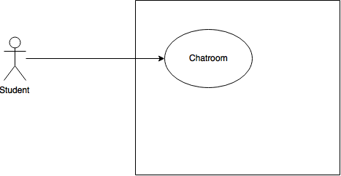

**Sequence Diagram**

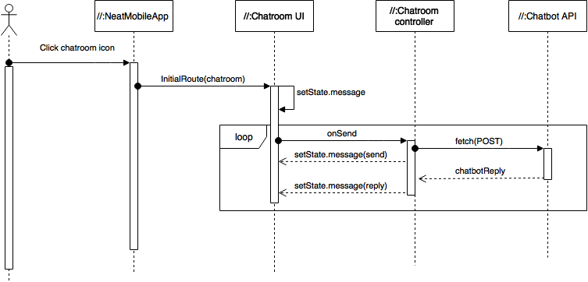

**Class Diagram**

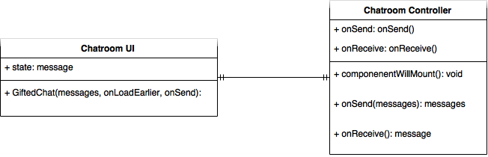

**Unit Test**

**Test Case 1 (Sunny Day)**

**Purpose**

* Ensure user can open the chatroom

**Precondition**

* User logged in

**Input**

* Chatroom icon pressed on TabBar

**Expected Result**

* Chatroom UI appears

**Actual Result**

* Chatroom UI appears

**Test Case 2 (Sunny Day)**

**Purpose**

* Ensure user can type input and have it appear in chat

**Precondition**

* User logged in
* User in chatroom UI

**Input**

* Keyboard presses

**Expected Result**

* Keyboard strokes appear on the screen after pressing enter

**Actual Result**

* Keyboard strokes appear on the screen after pressing enter

**Test Case 3 (Rainy Day)**

**Purpose**

* Ensure that if a user presses the chatroom icon while in the chatroom, the chat is not reset

**Precondition**

* In chatroom

**Input**

* Click chatroom icon

**Expected Result**

* No change in view

**Actual Result**

* No change in view

**Visual User Guide**

